Sentiment Analysis of Product Reviews using Machine Learning

Problem Id: 16

Student Name : Dhanvi Sarpal
University Roll number: 2025708
Section: G

Student Name : Garima Gupta
University Roll No.: 2029409
Section: G

Student Name : Ruhani Aneja
University Roll no.: 2028828
Section :G

TABLE OF CONTENTS

- Problem Description 3
- Architecture 4
- Models model 5
- Evaluation metrics used 6
- Preliminary Results and Visualizations 7
- References 8

- Problem Description

Sentiment analysis is the process of identifying the emotional tone behind a piece of text. In this project, we aim to develop a machine learning model that classifies product reviews into positive, negative, or neutral categories. With the rapid growth of e-commerce platforms, customers rely heavily on reviews before purchasing products. However, manually analyzing thousands of reviews is time-consuming and inefficient.
This project automates the process by using natural language processing (NLP) and machine learning techniques to extract meaningful insights from textual data. The system preprocesses the text, converts it into numerical features, and applies classification algorithms to predict sentiment. This helps businesses understand customer feedback, improve product quality, and enhance customer satisfaction. The project has real-life applications in online shopping platforms, social media monitoring, and customer service systems.

- Architecture

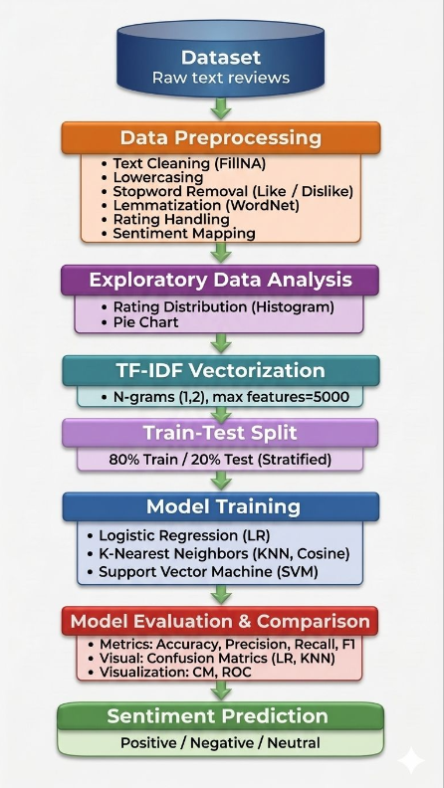

Fig.1 Sample flow diagram.
- Models Used(Applied/ Planned) Give a brief introduction of the models used

1. TF-IDF (Term Frequency–Inverse Document Frequency) – Feature Extraction Model
Before applying classification algorithms, the textual reviews are converted into numerical vectors using TF-IDF.
TF-IDF measures how important a word is in a review compared to the entire dataset. Frequently used meaningful words get higher importance, while common words get lower importance.
In this project, TF-IDF with unigram and bigram features helps transform cleaned review text into machine-readable form for sentiment prediction.

2. Logistic Regression (Applied)
Logistic Regression is a supervised machine learning classification algorithm used to predict categorical outputs such as Positive, Negative, or Neutral sentiment.
It works by calculating probabilities for each class based on input features and selecting the most likely category.
It is simple, fast, interpretable, and performs well for text classification problems, especially with TF-IDF features.
Role in project: Used as the primary baseline model for sentiment classification.

3. K-Nearest Neighbors (KNN) (Applied)
KNN is an instance-based learning algorithm that classifies a review based on the sentiment of its nearest neighboring reviews in feature space.
For a new review, the algorithm checks the K most similar reviews (using cosine similarity in this project) and assigns the majority sentiment class.
It is easy to understand and useful for comparison, though it can be slower on large datasets.
Role in project: Used to compare performance with other classification methods.

4. Support Vector Machine (SVM) (Applied)
SVM is a powerful classification algorithm that finds the best boundary (hyperplane) to separate different sentiment classes.
Using a linear kernel, it works effectively for high-dimensional text data such as TF-IDF vectors.
SVM is known for strong performance in text classification because it handles sparse data efficiently.
Role in project: Used as an advanced model for accurate sentiment separation.

Planned / Evaluation Models
Although Logistic Regression, KNN, and SVM are the main applied models, additional evaluation tools are planned to improve analysis:
- Confusion Matrix: To analyze correct and incorrect predictions class-wise.
- ROC Curve & AUC Score: To evaluate classification performance visually.
- Precision, Recall, F1-Score: To compare models beyond accuracy.

Best Performing Model in Current Phase:
Logistic Regression achieved the highest accuracy (~74.17%) among the implemented models, making it the most suitable model currently for this sentiment analysis system.

- Evaluation metrics used

Evaluation Metrics Used
To measure the performance of the sentiment analysis system, multiple evaluation metrics were used to compare Logistic Regression, KNN, and SVM models effectively.

1. Accuracy
Accuracy measures the overall percentage of correctly predicted sentiments out of all predictions made.
It shows how often the model predicts Positive, Negative, or Neutral sentiment correctly.
Formula:
Accuracy = (Correct Predictions / Total Predictions)
Role in project:
Used as the primary metric to compare overall model performance.

2. Precision
Precision measures how many of the reviews predicted as a particular sentiment were actually correct.
It focuses on prediction quality and reduces false positives.
Formula:
Precision = TP / (TP + FP)
Role in project:
Important when checking how reliable predicted sentiment labels are.

3. Recall
Recall measures how many actual sentiment instances were correctly identified by the model.
It focuses on reducing false negatives.
Formula:
Recall = TP / (TP + FN)
Role in project:
Useful for ensuring important sentiments are not missed.

4. F1-Score
F1-Score is the harmonic mean of Precision and Recall.
It provides a balanced measure when both false positives and false negatives matter.
Formula:
F1 Score = 2 × (Precision × Recall) / (Precision + Recall)
Role in project:
Used for balanced comparison of all models.

5. Confusion Matrix
A Confusion Matrix is a table that shows:
- Correct Positive predictions
- Correct Negative predictions
- Correct Neutral predictions
- Incorrect classifications between classes
Role in project:
Helps visualize where the model is making mistakes.

6. ROC Curve (Receiver Operating Characteristic Curve)
ROC Curve plots True Positive Rate against False Positive Rate at different thresholds.
Role in project:
Used to analyze the model’s classification ability visually.

7. AUC Score (Area Under Curve)
AUC measures the area under the ROC curve.
Higher AUC means better model performance.
Role in project:
Used to compare classification strength of models.

Multiple Metrics were used because:
Sentiment analysis is a multiclass classification problem (Positive, Negative, Neutral), relying only on accuracy may not give complete performance insight. Therefore, Precision, Recall, F1-Score, Confusion Matrix, and ROC/AUC were used for a more detailed and reliable evaluation.

Final Comparison Basis:
The models were mainly compared using:
Accuracy + Precision + Recall + F1-Score, with Logistic Regression showing the best overall performance in the current implementation.

5. Preliminary Results and Visualizations

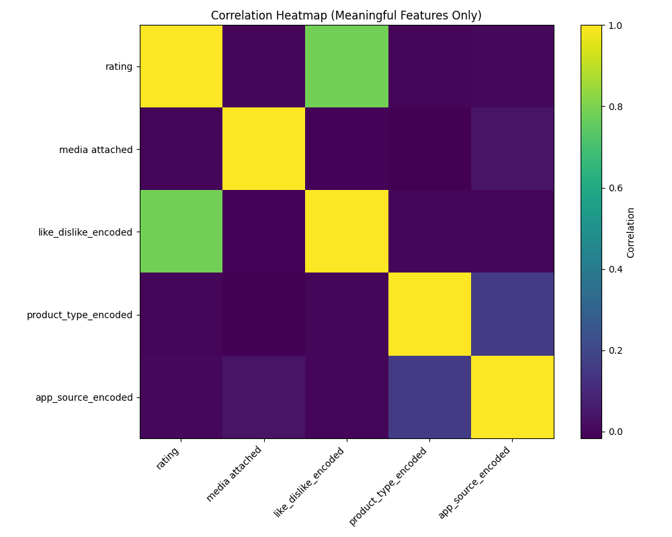
Fig.2 Heatmap showing correlation

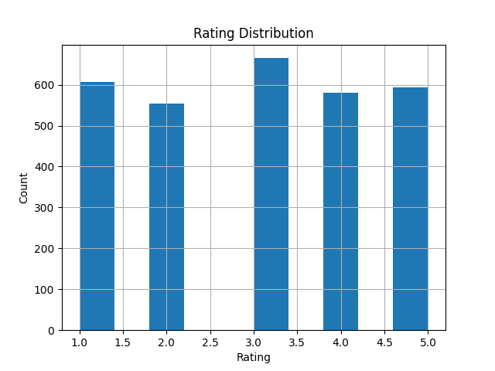
Fig.3
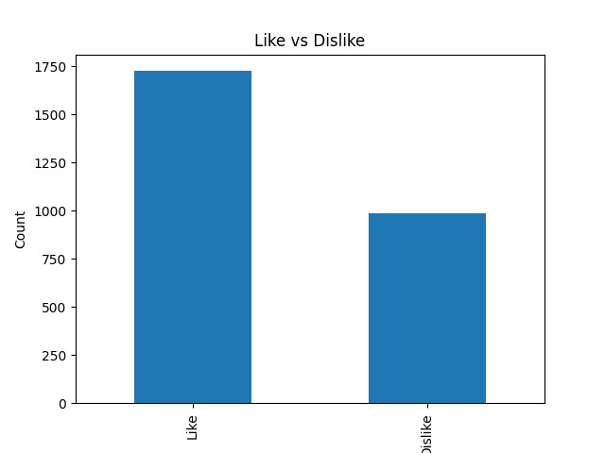
Fig.4

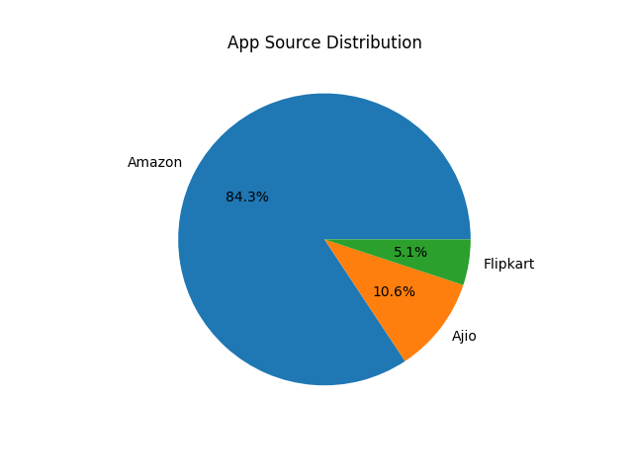
Fig.5

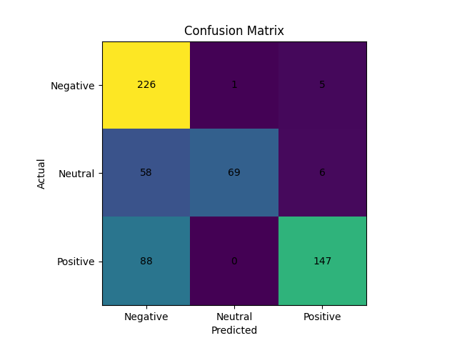

Fig.6

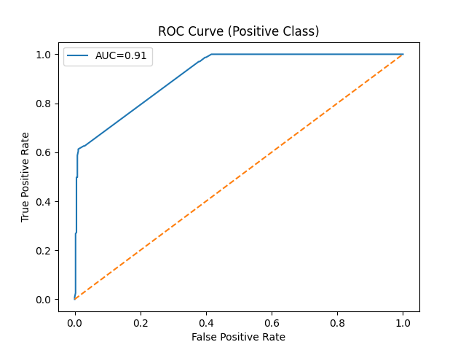
Fig.7

6. References:

- Platform Required:

Google Colab / Jupyter Notebook

- Books and Link Sources:
1.“Python for Data Analysis” by Wes McKinney
2. GeeksforGeeks (https://www.geeksforgeeks.org)
3. Scikit-learn official documentation
4. Kaggle datasets (https://www.kaggle.com)

